***Project Final Report***

***On­­­***

**Snack Shack Café (Website)**

Submitted in the partial fulfillment for the award of the degree of

BACHELOR OF ENGINEERING

**COMPUTER SCIENCE & ENGINEERING**



**Submitted to: Submitted By:**

(Namrata & Ecode – E137 Darshan (20BCS2353)

**Project Teacher (Supervisor)** Sayan Sarkar (20BCS2299)

Atul (20BCS2271)

**Co Supervisor Signature**

(Akshay Kumar & E Code -E13385)

**DEPARTMENT OF COMPUTER SCIENCE & ENGINEERING**

**CHANDIGARH UNIVERSITY, GHARUAN**

**June 2023**



## BONAFIDE CERTIFICATE

Certified that this project report **“_ Snack Shack Café [website] ”** is the bonafide work of “**Darshan, Sayan Sarkar,** and **Atul ”** who carried out the project work under my/our supervision.

**SIGNATURE SIGNATURE**

**SUPERVISOR HEAD OF THE DEPARTMENT**

Submitted for the project viva-voce examination held on 15 May 2023__

**INTERNAL EXAMINER EXTERNAL EXAMINER**

**ABSTRACT**

This report is conducted in order to set the foundations upon which the final project. The title of the project is: “**Snack Shack Cafe**”. It is a website that is used to display the data of a café or can help to convert the traditional café into online and is supervised by **Namrata.**

The Primary goal of this website is to make the interaction of users/customers with café very smoothly and increase the sales and customer relationship.

Snack Shack Cafe website is developed for a traditional Snack Shack Café. The purpose of this website is to automate the existing manual system to help the computerized equipment and full-fledged computer software, fulfilling their requirements, so that their valuable data/information can be stored for a longer period with easy accessing and manipulation of the same. The required software and hardware are easily available and easy to work with.

The website uses programming languages HTML, CSS, and Java Script in the frontend and PHP and MY SQL in the backend. The main purpose of this website is to help in attracting the new users/customers and selling the café items online like swiggy. Using the website any user can look at the dishes, search any particular dish and order it very easily. Software provides a very interactive and user friendly interface. Any user can order the food at anytime and anywhere just by pressing one click.

The website provides the following benefits to the user:

* Interactive and user friendly UI/UX
* Chat bot
* AI recommendations
* UPI payment/COD/using web wallet
* Contact form for any particular problems
* Map location of the café
* Discounts banners
* Order slip for betterment

HTML, CSS is used to make the project outlook fascinating. JS is helping in adding some animations on our website. PHP for signup, login, searching and for admin panel connecting. MySQL will be used to collect the data of the café products or users and for handling databases. In future we are also planning on adding a Chat Bot with the help of AI to assist the new visitors.

**ABSTRACT[in Hindi]**

यह रिपोर्ट अंतिम परियोजना की नींव रखने के लिए आयोजित की जाती है। परियोजना का शीर्षक है: "स्नैक शैक कैफे"। यह एक ऐसी वेबसाइट है जिसका उपयोग किसी कैफे के डेटा को प्रदर्शित करने के लिए किया जाता है या पारंपरिक कैफे को ऑनलाइन में बदलने में मदद कर सकता है और नम्रता द्वारा इसकी देखरेख की जाती है।

इस वेबसाइट का प्राथमिक लक्ष्य कैफे के साथ उपयोगकर्ताओं/ग्राहकों की बातचीत को बहुत सुचारू बनाना और बिक्री और ग्राहक संबंधों को बढ़ाना है।

स्नैक शेक कैफे वेबसाइट पारंपरिक स्नैक शेक कैफे के लिए विकसित की गई है। इस वेबसाइट का उद्देश्य कम्प्यूटरीकृत उपकरण और पूर्ण विकसित कंप्यूटर सॉफ्टवेयर की मदद के लिए मौजूदा मैनुअल सिस्टम को स्वचालित करना है, जिससे उनकी आवश्यकताओं को पूरा किया जा सके, ताकि उनके मूल्यवान डेटा/सूचना को आसान पहुंच और हेरफेर के साथ लंबी अवधि के लिए संग्रहीत किया जा सके। . आवश्यक सॉफ़्टवेयर और हार्डवेयर आसानी से उपलब्ध हैं और इनके साथ काम करना आसान है।

वेबसाइट प्रोग्रामिंग लैंग्वेज HTML, CSS और Java Script को फ्रंटएंड में और PHP और MY SQL को बैकएंड में इस्तेमाल करती है। इस वेबसाइट का मुख्य उद्देश्य नए उपयोगकर्ताओं/ग्राहकों को आकर्षित करने और स्विगी जैसे कैफे आइटम को ऑनलाइन बेचने में मदद करना है। वेबसाइट का उपयोग करके कोई भी उपयोगकर्ता व्यंजनों को देख सकता है, किसी विशेष व्यंजन को खोज सकता है और उसे बहुत आसानी से ऑर्डर कर सकता है। सॉफ्टवेयर एक बहुत ही इंटरैक्टिव और उपयोगकर्ता के अनुकूल इंटरफेस प्रदान करता है। कोई भी यूजर सिर्फ एक क्लिक करके किसी भी समय और कहीं भी खाना ऑर्डर कर सकता है।

प्रोजेक्ट आउटलुक को आकर्षक बनाने के लिए HTML, CSS का उपयोग किया जाता है। जेएस हमारी वेबसाइट पर कुछ एनिमेशन जोड़ने में मदद कर रहा है। साइनअप, लॉगिन, खोज और एडमिन पैनल कनेक्ट करने के लिए PHP। MySQL का उपयोग कैफे उत्पादों या उपयोगकर्ताओं के डेटा एकत्र करने और डेटाबेस को संभालने के लिए किया जाएगा। भविष्य में हम नए आगंतुकों की सहायता के लिए एआई की मदद से चैट बॉट जोड़ने की भी योजना बना रहे हैं।

## ACKNOWLEDGEMENT

### It is my pleasure to be indebted to various people, who directly contributed to the development of this work and who influenced our thinking, behavior and acts during the course of study.

We are thankful to our Project Teacher or Supervisor **Namrata Mam** for her support, cooperation and motivation provided to us during the training for constant inspiration, presence and blessings.

We would also like to thank our Co Supervisor **Akshay Kumar Sir** for his valuable suggestions and precious time which helps us a lot in completion of this project.

Lastly, we would like to thank the almighty and our parents for their moral support and friends with whom we shared our day-to-day experience and received lots of suggestions that improved our quality of work.

## TABLE OF CONTENTS

List of Figures....................................................................................................................... 7

**CHAPTER 1. INTRODUCTION....................................................................... 8**

1.1. Problem Identification…………………………………...…......................................... 9

1.2. Project Scope ………..................................................................................................... 10

1.3. Project Planning and Task Definition.............................................................................. 10

1.4. Timeline ......................................................................................................................... 11

**CHAPTER 2. LITERATURE REVIEW/BACKGROUND STUDY ............. 12**

2.1. Existing solutions........................................................................................................... 13

2.2. Goals/Objectives ............................................................................................................ 14

**CHAPTER 3. DESIGN FLOW/PROCESS ....................................................... 15**

3.1. Feature/ Characteristics Identification.......................................................................... 15

3.2. Design Constraints/ Constraints Identification.............................................................. 16

3.3. Analysis of Features and finalization subject to constraints .......................................... 17

3.4. Design selection ............................................................................................................. 18

3. 4.1 DFD Design Flow…………………………………………………………………19

3.4.2 Use Case Diagram …………………………………………………………………20

3.4.3 Sequence Diagram ………………………………………………………………….21

**CHAPTER4. DETAILED SYSTEM DESIGN/TECHNICAL DETAILS ……..22**

4.1. Modern Tools Used In Design and Analysis ................................................................ 22

4.2. System Specification .................................................................................................... 23

4.3 Project Screen Shots ...................................................................................................... 24

**CHAPTER5. RESULT ANALYSIS AND VALIDATION ……………………..30**

5.1. Result Analysis............................................................................................................... 30

**CHAPTER 6. CONCLUSION AND FUTURE WORK .................................. 31**

6.1. Conclusion/Deviation from expected Outcome and Ways Ahead................................. 31

6.2. Achievements....................................................................................................................32

6.2. Future work/Future Scope................................................................................................. 32

**REFERENCES ....................................................................................................... 33**

**APPENDIX ............................................................................................................. 34**

1. Plagiarism Report ............................................................................................................... 36

2. Design Checklist ................................................................................................................ 37

## LIST OF FIGURES

1. Figure 1.4[Time Line Chart]………………………………………………………………..
2. Figure 3.1[Component Diagram]……………………………………………………………
3. Figure 3.4.1(a)[Level Zero DFD]……………………………………………………………
4. Figure 3.4.1(b)[Level 1 DFD]……………………………………………………………….
5. Figure 3.4.1(c)[Level 2 DFD]……………………………………………………………….
6. Figure 3.4.2[use case diagram]…………………………………………………………........
7. Figure 3.4.3[Sequence Diagram]……………………………………………………….........
8. Figure 4.3.1[Front Page]…………………………………………………………………….
9. Figure 4.3.2[Home Page-1]………………………………………………………………….
10. Figure 4.3.3[Home Page-2]………………………………………………………………….
11. Figure 4.3.4[About Page]……………………………………………………………………
12. Figure 4.3.5[Testimonials Page]…………………………………………………………….
13. Figure 4.3.6[Contact Page]………………………………………………………………….
14. Figure 4.3.7[Login Page]……………………………………………………………………
15. Figure 4.3.8[Cart Page]……………………………………………………………………...
16. Figure 4.3.9[Checkout Page]………………………………………………………………...
17. Figure 4.3.10[Order Success Page and mail notification]…………………………………...
18. Figure 4.3.11[Founder’s Page]………………………………………………………………
19. Figure 4.3.12[Admin Login Page]…………………………………………………………...
20. Figure 4.3.13[Admin Dashboard Page]………..…………………………………………….
21. Figure 4.3.14[Admin Order Master Page]……………………………………………………
22. Figure 4.3.15[Admin Dish Master Page]…………………………………………………….
23. Figure 4.3.16[Delivery Boy Login Page]…………………………………………………….
24. Figure 4.3.17[Delivery Boy Dashboard Page]…………………...…………………………..
25. Figure 4.3.18[Order PDF]……………………………………………………………………

**Chapter - 1**

**INTRODUCTION**

The traditional system is a restaurant or cafe paper menu and ordering system is replaced with an electronic medium i.e. a Snack Shack Café website. Due to a digitalized system, the risk of manual errors is eliminated, thus eliminating the communication barrier.

The website displays all the information the customer needs to know about the order he has placed. It has been developed to override the problems prevailing in practicing manual system. This software is supported to eliminate and in some cases reduce the hardships faced by this in existing system. Moreover this system is designed for the particular need of the company to carry out operations in a smooth and effective manner.

This website is reduced as much as possible to avoid errors while entering the data. It also provides error message while entering invalid data. It is user friendly. It can lead to error free, secure, reliable and fast management system. It can assist the user to concentrate on their other activities rather to concentrate on the record keeping. It will help organization in better utilization of resources.

This self-service fast food restaurant will be equipped with a user-friendly touch screen, a credit/debit card reader, and software for completing the process at the backend. For this system there will be a system administrator who will have the rights to enter the menu with their current prevailing prices. He/she can enter anytime in the system by a secured system password to change the menu contents by adding or deleting an item or changing its price.

Now when the customer enters the restaurant, he will place his order with the help of the touch screen using the intuitive graphical user interface, right from the selection of language till the payment confirmation. He will select from the food options according to his choice and the system will display the payment amount he has to make once he has finished with his order.

Customer gets many benefits via online ordering this helps cafeteria to build long-lasting and profitable relationship with their customers. For making strong relationship with these users it is very important to focus on the customer as a whole and making sense of a flood of real-time information that goes well beyond demographics or shopping behavior.

There are two entities that will have the access to the system. One is the admin and another one will be the registered user. Admin can add product details, view all the order details and can also view the sales of the products.

User need to register with basic registration details to generate a valid username and password. After the user logins, it can view all the products that are recommended on the homepage compiled by the system based on user’s information. From the recommended menu card, the user can even further view its details and then if interested to order, the system gives add to cart option for purchasing the product.

The system even has an AI bot with the help of which the user can get answers to queries like prices, facilities, etc. details of the cafeteria. This AI Bot even converts text to speech. After selecting the particular food, user can do payment for the particular food online. Users can view their order history of their purchased food. They can also show their delivery boy details too.

Every organization whether big or small, has challenges to overcome and managing the information. So, we design exclusive employee management systems that are adapted to our managerial requirements. This is designed to assist in strategic planning, and will help us to ensure that our organization is equipped with the right level of information and details of our future goals. Also, it allows us to manage work from anywhere anytime. These systems will ultimately allow us to better manage resources.

**1.1 PROBLEM DEFINATION:**

In the traditional café’s or food cots customers can visit and then order his/her dish and spend time and money for travelling and ordering food in traditional manner. This whole process takes lot of the precious time. As the world go toward digital people are happier to spend time with smart phone and tabs. Now time is more important. So, due to this problem using Snack Shack Café Website convert the traditional café into online. This provides both laptop and Mobile views. Using the Snack Shack web any one can order his/her food in just one click.

**1.2 PROJECT SCOPE:**

Snack Shack Cafe Website has the following Scopes:-

The Primary goal of this website is to make the interaction of users/customers with café very smoothly and increase the sales and customer relationship.

The Secondary goal of this website is to display the café products and dishes, so that users can easily see the products and order their dish online just pressing one click.

This type of website provides basic information about the cafe, such as its location, hours of operation, menu, and contact information. It can also include photos of the cafe and its food, as well as customer reviews or testimonials.

The café website also has an events calendar that can provide customers with information about upcoming events at the Snack Shack cafe, such as live music performances or special promotions.

**1.3 PROJECT PLANNING AND TASK DEFINITION:**

We are developing a website for a cafeteria using HTML, CSS, and JS in the frontend and PHP as the backend. The main purpose of this website is to help the online business and manage the Snack Shack café online. HTML, CSS is used to make the project outlook fascinating. JS is used to add animations on our website. PHP is used for signup, login page, add to cart, search page and for payment gateway. MySQL will be used to collect the data of the customers or users. The working of this website is to order food, book tables, café party hall online at any time without delay and going anywhere. We can also add a chat bot with the help of AI to assist the new visitors.

The website provides the following benefits to the user:

* Interactive and user friendly UI/UX
* Chat bot
* AI recommendations
* UPI payment/COD/using web wallet
* Contact form for any particular problems
* Map location of the café
* Discounts banners
* Order slip for betterment

According to the need of the project HTML5 CSS are used to make the project outlook fascinating. JS is helping in adding some animations on our website. PHP for signup, login, searching and for admin panel connecting. MySQL will be used to collect the data of the dishes/products or users and for handling databases. In future we are also planning on adding a Chat Bot with the help of AI to assist the new visitors.

**1.4 Timeline:**

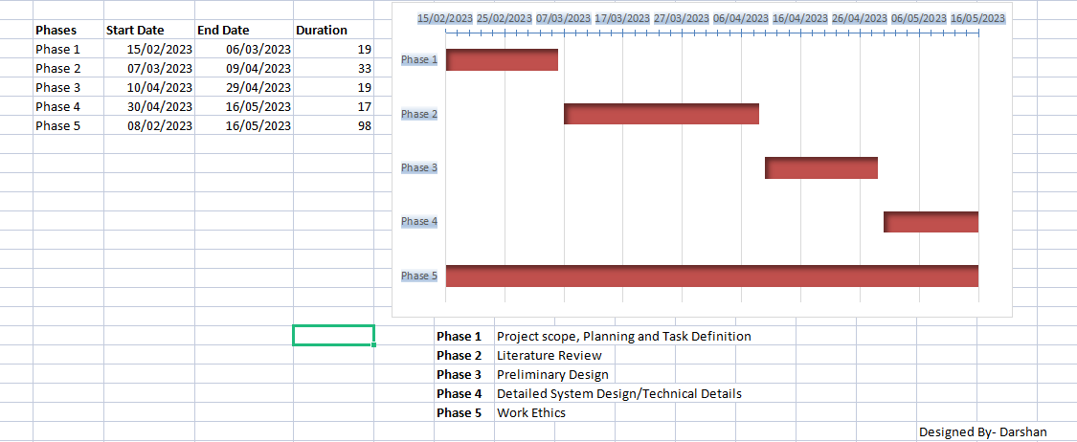

Figure 1.4[Timeline Diagram]

**Chapter – 2**

**LITERATURE SURVEY**

The Snack Shack Cafe website is implemented to reduce the manual work and enhances the accuracy of work in a restaurant so employment can be increased. The website allows the user to order the traditional and authentic food from the comfort of their home. This website also manages and maintains the record of customers and their order online. This website has been made in a user friendly interface. So that Customers can add and delete the food items easily and can do payment without any trouble. The complete website is designed by analysis of many other food ordering, restaurant management systems, hotel management systems, reports and journals & articles. Some common literatures are as follow:

[1][*Alimul Rajee || ( 2022).*](https://www.researchgate.net/publication/367179633_ONLINE_FOOD_ORDERING_SYSTEM)

The purpose of [Online Food Ordering System](https://www.researchgate.net/publication/367179633_ONLINE_FOOD_ORDERING_SYSTEM) is to automate the existing manual system by the help of computerized equipment and full-fledged computer software, fulfilling their requirements, so that their valuable data/information can be stored for a longer period with easy accessing and manipulation of the same. The required software and hardware are easily available and easy to work with. The Online Food Ordering System's main purpose is to maintain track of information such as Item Category, Food, Delivery Address, Order, and Shopping Cart. It keeps track of information about the Item Category, the Customer, the Shopping Cart, and the Item Category. Only the administrator gets access to the project because it is totally built at the administrative level. The project's purpose is to develop software that will cut down on the time spent manually managing Item Category, Food, Customer, and Delivery Address. It saves the Delivery Address, Order, and Shopping Cart information.

[2] [*Tejas Raibagi, Ashwin Vishwakarma & Jahnavi Naik || (2021*](https://ieeexplore.ieee.org/document/9396040)).

In today's world, with people hustling for their jobs all the time, a huge count of people doesn’t have the time to actually prepare their lunch and here canteen plays a major role. But then again people are in a rush and don't have much time to spend in the canteen as well to place an order or wait until their order is ready. This project is based on an AI-based cross-platform application that focuses on automating all the major canteen functionalities. It enables the user to register online, browse and choose from an E-menu card followed by placing the order and receiving confirmation after successful payment. With the help of this app, students and faculties can order food beforehand and can receive it during the break to ensure that the time spent in ordering and collecting the order is as low as possible. The app also docks in AI, which will help the users to get personal recommendations and food items which are popular amongst others. The objective is to reduce the manual paperwork as the app digitalizes every factor and provides a graphical representation of daily sales and allows comparison for weekly, monthly and annual sales. The feedback system allows the admin to monitor the app and make changes based on the user feedback.

[3][*Cristina-Edina Domokos, Barna Sera, Karoly Simon, Lojos Kovacs & Tas-Bela || (2018*](https://ieeexplore.ieee.org/document/8524854)*).*

Netfood is order management software for food delivery companies. It is a delivery-oriented system that allows clients to order from multiple restaurants at the same time, and provides the possibility to order individually or in a group. Orders can be placed by users through the web interface. The data related to restaurants, foods and orders is managed by administrators. A mobile application is used by the delivery personnel. Both client applications are served with data by a central server. The article presents the architecture and the implementation of the software system. The technologies, tools and methods used during the development process are also described.

[4][*Tang Bin, Xu Hongzhen & Song Wenlin || ( 2009*](https://ieeexplore.ieee.org/document/5288330/)*).*

Current wireless communications enable people to easily exchange information, while web services provide loosely-coupled and platform-independent ways of linking applications across the Internet or Intranet. This paper presents an integration of wireless communication technologies and web services technologies to realize a wireless food ordering system. In this system, it implements wired and wireless data access to the servers and food ordering functions through both desktop PCs and mobile devices such as PDAs over a wired/wireless integrated local area network. To sure the security of the system, the secure web service architecture and some security strategies to ensure mobile communication security are discussed. Web services-based wireless applications on mobile devices provide a means of convenience, improving efficiency and accuracy for restaurants by saving time, reducing human errors, etc.

**2.1 EXISTING SOLUTION:**

There are many existing online food ordering websites, or café websites witch offer online food ordering facility to the users by website or applications. Here are a few examples:-

1. Grubhub - offers a wide range of cuisines and food types, with delivery and pickup options available.

2. Zomato - offers food delivery and pickup options from a variety of restaurants in many countries, with a focus on providing detailed information about restaurants and menus.

3. Swiggy - offers food delivery and pickup options from a variety of restaurants in India.

4. Talabat - offers food delivery and pickup options from a variety of restaurants in many countries in the Middle East.

**2.2 OBJECTIVE:**

The Primary goal of this website is to make the interaction of users/customers with café very smoothly and increase the sales and customer relationship. Secondly, this website also helps to display the café products and dishes, so that users can easily see the products and order their dish online just by pressing one click.

Functionalities provided:

* **UI/UX Design:** The Snack Shack café website provides a very interactive and user friendly user interface for the users as well as for the administrator or owner of the website. Where users can very easily order food and the admin can very easily handle all the orders in the database of the site.
* **Tracks Information:** The website is designed using some JS algorithms. Which helps in tracking the information of the users detail as well as the orders details in the software? This process helps in managing the database and increasing the sales and customers of Snack Shack Café.
* **Recommendations:** Software also uses AI and ML for providing the recommendations to the user according to the previous order or using most like dish data. This feature is different from other web applications.
* **Chatbot:** Chatbot is specially designed for providing answers to the common questions of the clients regarding the website or their order etc. Chatbots help and provide instant solution to the user’s questions and also help the café to interact with more and more users toward the website.
* **Data Encryption:** The Snack Shack Café website also has the unique feature of converting the plain text or data into cipher text before storing to the database using addition of parity bits in the data. Which helps to protect the site from various attacks or unauthorized users?

**Chapter – 3**

**DESIGN/FLOW PROCESS**

**3.1 FEATURE/CHARACTERISTICS IDENTIFICATION:**

There are the following features of Snack Shack Cafe:-

1. **Inventory Control:** The Snack Shack Cafe has an inventory control feature. The System has the option of deducting items from the inventory when the product is sold. For instance, if a fries is sold, the app should subtract the fries from inventory. This way, you know what amount of food you have and how much is required. Inventory is essential as you wish to understand your profit margins by knowing the consumption of food. All the systems should have inventory control or may require third-party integration. So, you should know what all you need for inventory management.
2. **Business Reporting Ability:** Software also works on a business reporting system or on sending alert messages regarding our cafe to the admin. As a business owner, you don’t have time to evaluate in detail how your business is performing in a particular area. The business reporting system of the management app should be flexible so that it works automatically and sends alerts based on predetermined, user-defined performance indicators. This saves a lot of time and also gives access to all the operations. You can then proactively address the issues that are becoming obstacles in the path of your business growth.
3. **User-Friendly System:** The interface of the website is user friendly and interactive. If any new person comes he/she can easily handle and can easily order their food in a few seconds. The Snack Shack Cafe admin panel is also user-friendly. Admin can easily add or delete any food at any time by pressing one click.
4. **Technical Support:** The Snack Shack Cafe also provides technical support to users. The website provides live chart facility. Which help the users if anyone faces any technical issue during ordering the food.

**3.2 CONSTRAINTS IDENTIFICATION:**

The following Constraints come in the project:

1. **Time:** Time is the first constraint in designing the Snack Shack Café website. Time is a key element to a project’s success. After all, what good is a finished product if it is completed long after the expected deadline? To overcome this constraint our project team first design the time table and divide the project according to the time table. Time Management also helps in increasing the speed of the project.
2. **Quality:** Quality is another constraint that Snack Shack Café has. The quality constraint focuses on the characteristics of the deliverable or product. In general, the quality of the project will be evaluated by how closely the outcome matches the expectations set in the planning stages.
3. **Customer Satisfaction:** Another constraint to bear in mind is customer satisfaction. When thinking about customer satisfaction as a constraint, our team needs to keep in mind that we design a simple and interactive user interface. So to overcome this constraint we add JavaScript to the website for a responsive and interactive look to the User Interactive [UI] elements.
4. **Resources:** Resources is one of the constraints that we face in designing the project. To avoid the effects of this constraint our team takes help of Google, friends and also collects the resources from different other Cafe websites & journals.
5. **Manufacturability:** Manufacturability is one of the most important constraints of this software. Because designing multi task and multi process software is one of the complex tasks. But with the help of PHP the software design in such a way that it provide Users interface, Admin interface and also a Delivery boy interface.

**3.3 ANALYSIS OF FEATURES & FINALIZATION SUBJECT TO CONSTRAINTS:**

Despite having a lot of constraints and risks, till now, we have achieved the feat of minimizing them and we hope to do so in the upcoming phases of the project. After analyzing all the aspects of our project i.e. features and possible constraints, we have decided on certain features for our project that will be suitable.

Major among them are listed below:

1. **Live Chat:** A feature where your operators initiate the chat and reach out to your website visitors by offering instant help. This is a powerful tool for increasing customer satisfaction and engagement. By providing instant solution of visitor’s doubts and problems regarding their order or payment.
2. **Payment Mode:** Payment is one of the constraints. This is solved by the team of Snack Shack Café during planning and designing time by providing the feature of all UPI payments, net-banking, credit along with website own cash wallet or Debit card facility and by also providing pay on delivery for some products.
3. **Analytics and reporting:** Analytics gives you visibility into key areas of your operation and is arguably the most defining feature of cafe management software. We can use analytics to know which problems to attack first. We can analyze this using Customer data, Sales and menu analytics and Inventory and procurement analytics.
4. **AI Support:** AI (Artificial Intelligence) is used in the web software for providing recommendations to the regular customers by analysis of previous order and most liked food. AI also helps to the admin for making report of the sales.
5. **Café App:** For android users or regular customers the Snack Shack Café software also provides android application which helps in saving time of login website for every order and also provides notification of offers.

**3.4 DESIGN SELECTION:**

The Snack Shack Cafe system is designed based on a mixture of multitier architecture, RESTFUL architecture style [5] and Model View View Model (MVVM) pattern [7]. The multi tier architecture provides a model to create flexible and reusable components in a web application. It segregates the application into several tiers, where developers can add/modify the functionalities on a certain tier instead of modifying an entire application. This allows the functionalities of the system to extend for future development.

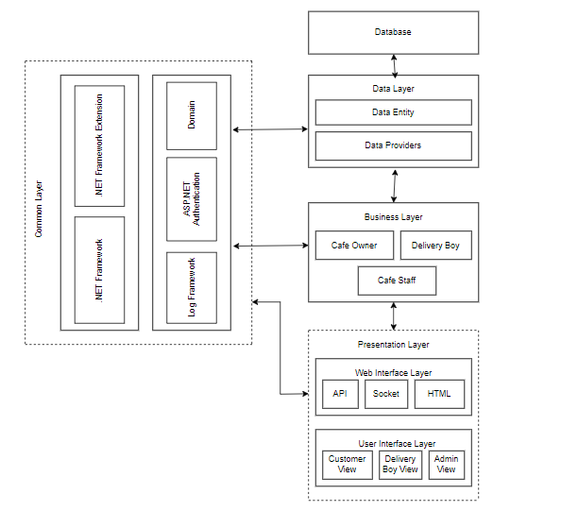

Figure 3.4[Component Diagram]

The RESTFUL architecture style provides core functionalities of the system as web services for different devices and platforms as mentioned in requirements R1, R2 and R5. The MVVM pattern [7] allows developing the User Interface (UI) with clear separation of UI components and presentation logic. The core system has three main layers: Data Layer, Business Layer and Presentation Layer. The Presentation Layer is further divided into two layers, namely Web Interface and UI Layers. These two layers are loosely coupled and connected with web services. All these layers are cross-connected with the Common Layer, as shown in Figure 4.1.

**3.4.1 DFD ON CAFTERIA MANAGEMENT SYSTEM:**

* Level Zero Diagram:

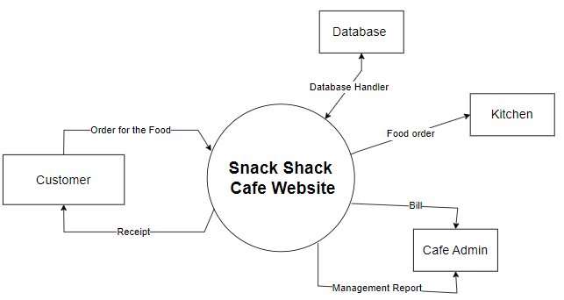

Figure 3.4.1(a)[Level Zero DFD]

* Level One Diagram:

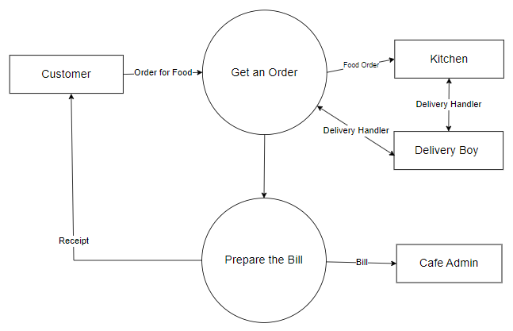

Figure 3.4.1(b)[Level 1 DFD]

* Level Two Diagram:

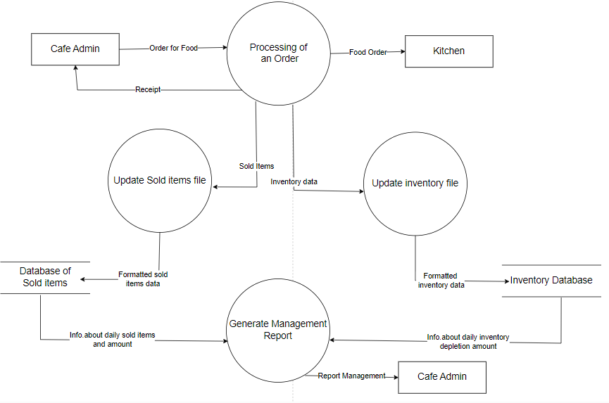

Figure 3.4.1(c)[Level 2 DFD]

**3.4.2 Use Case Diagram:**

Use-case diagrams describe the high-level functions and scope of a system. These diagrams also identify the interactions between the system and its actors. The use cases and actors in use-case diagrams describe what the system does and how the actors use it, but not how the system operates internally.

Here users and admin are the actors and the working of the system is use cases.

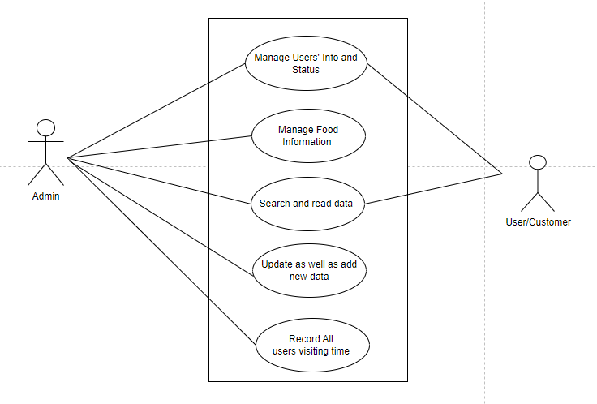

Fig 3.4.2[use case diagram]

**3.4.3Sequence Diagram:**

A sequence diagram is a type of interaction diagram because it describes how—and in what order—a group of objects works together. These diagrams are used by software developers and business professionals to understand requirements for a new system or to document an existing process. Here this sequence diagram shows how the system works in step by step.

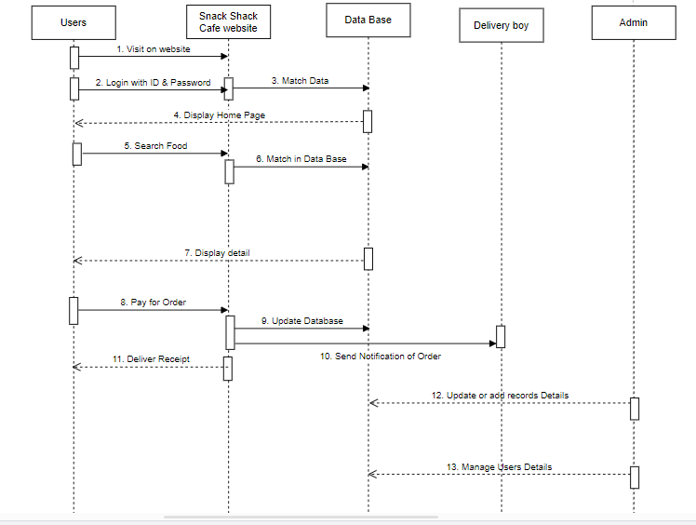

Fig 3.4.3 [Sequence Diagram]

**Chapter – 4**

**DETAILED SYSTEM DESIGN/TECHNICAL DETAILS**

**4.1 Modern Tools Used In Design and Analysis:**

The name ‘Snack Shack Cafe’ suggests that this is any café or food ordering website. This software can be design with the help of many programming languages like HTML, CSS, JS, PHP, My SQL, and many more. To handle these languages we use entire initial tools that we need for making any website.

**Software tools:**

* **VS Code**:

Visual Studio Code is a streamlined code editor with support for development operations like debugging, task running, and version control. It aims to provide just the tools a developer needs for a quick code-build-debug cycle and leaves more complex workflows to fuller featured IDEs, such as Visual Studio IDE.

* **My SQL**:

MySQL is an open-source relational database management system. Its name is combination of “My”, the name of co-founder Michael Widenius's daughter, and "SQL", the abbreviation for Structured Query Language. In Snack Shack this use for making the database of the whole website.

* **XAMPP Server**:

XAMPP helps a local host or server to test its website and clients via computers and laptops before releasing it to the main server. It is a platform that furnishes a suitable environment to test and verify the working of projects based on Apache, Perl, MySQL database, and PHP through the system of the host itself.

* **Tidio**:

[Tidio.com](https://www.tidio.com/panel/login) is a site that provides chat bot to Snack Shack Cafe web. This provides live chat with the admin as well as inbuilt chats or AI chat for the users. Which helps the clients if they face any problem in operating the website or for solving common FQ of customers?

* **Pinterest**:

Pinterest is a social site where you can collect and share images of anything you find interesting. You can also visually discover new interests by browsing the collections of other [Pinterest users](https://www.lifewire.com/most-popular-pinterest-users-to-follow-3485976). We use this site for collecting all the images for the website.

* **Sublime text**:

Sublime Text is a shareware cross-platform source code editor. It natively supports many programming languages and markup languages. Users can expand its functionality with plug-in, typically community-built and maintained under free-software licenses. To facilitate plug-ins, Sublime Text features a Python API. The whole Snack Shack website phages are coded in the sublime text editor. This is an advanced editor which mainly helps in making HTML, CSS, JS, PHP files.

* **Infinityfree:**

Infinity free is a software or website hosting site. Snack Shack Cafe use this software to host or publish the website. Infinityfree provides Control Panel, File Manager, MySQL database, Domain and SSL certificate to the website.

**4.2 System Specification:**

The hardware and software requirements for the development phase of our projects are:

**Software requirements:**

* Windows 10/ 11
* VS Code/Sublime text
* Mysql
* XAAMP Server

**Hardware requirements:**

* Dual-core 32/64-bit processor.
* Upto 4GB of memory.
* Upto 4GB of internal storage Android SDK:2GB
* Windows SDK: 4GB.
* Network interface card
  1. **Project Screen Shot:**

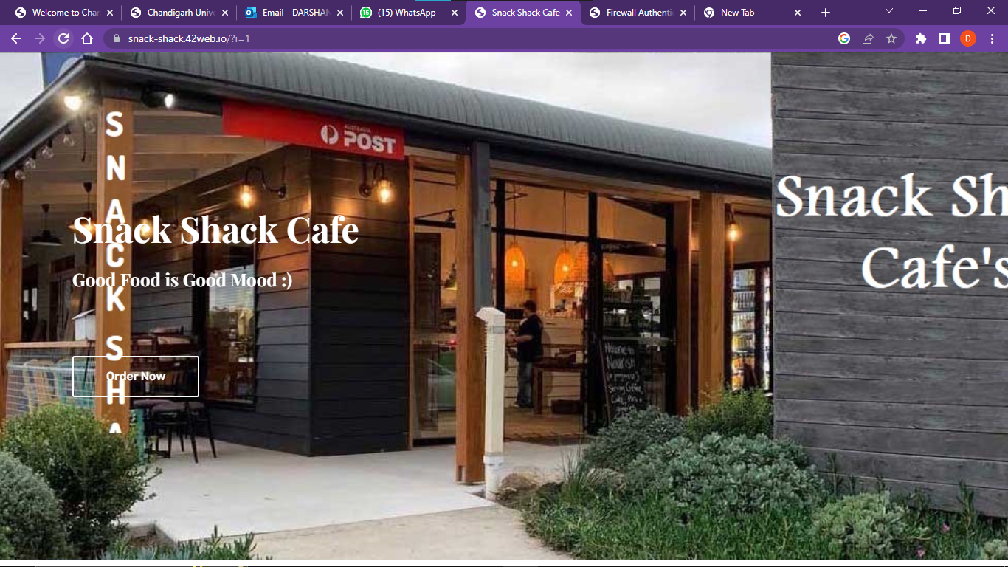

Figure 4.3.1[Front Page]

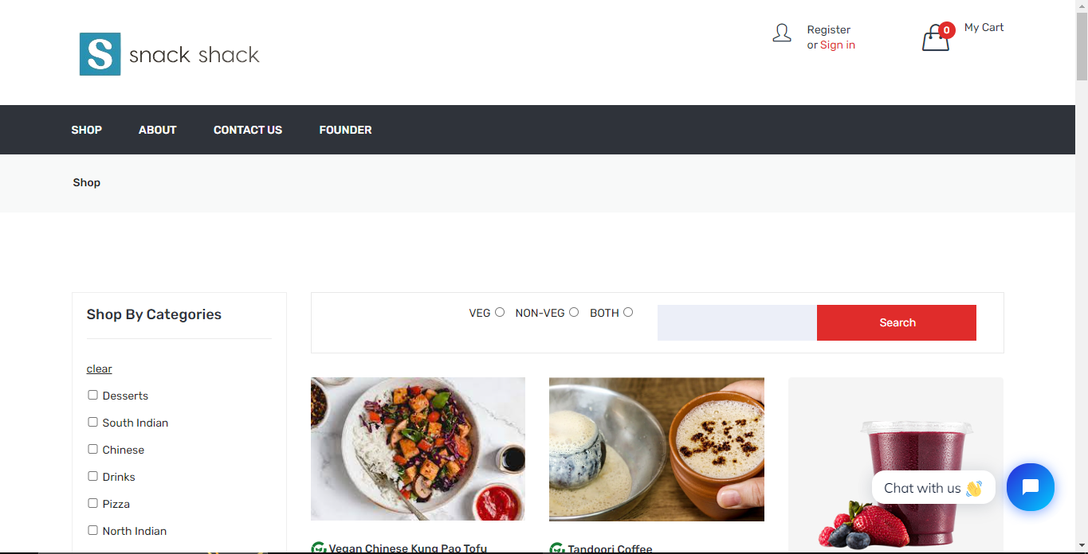

Figure 4.3.2[Home Page-1]

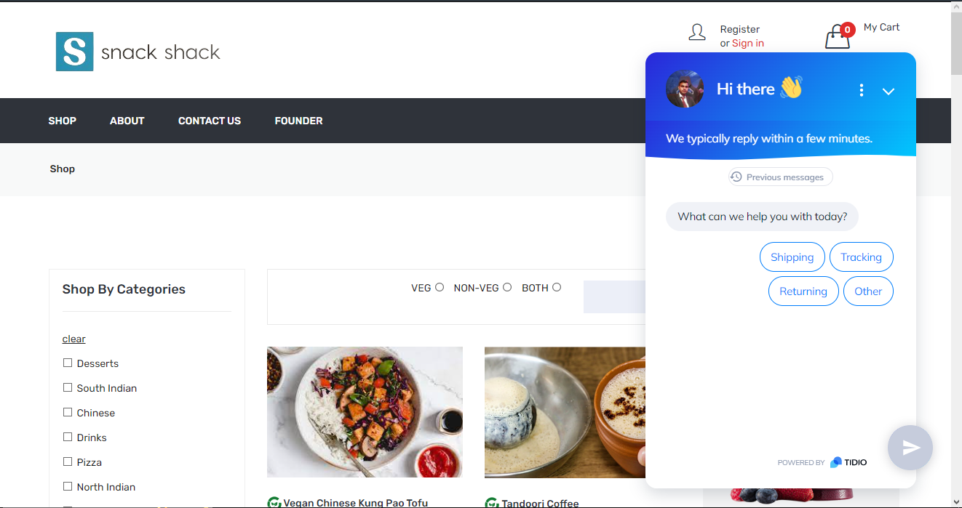

Figure 4.3.3[Home Page-2]

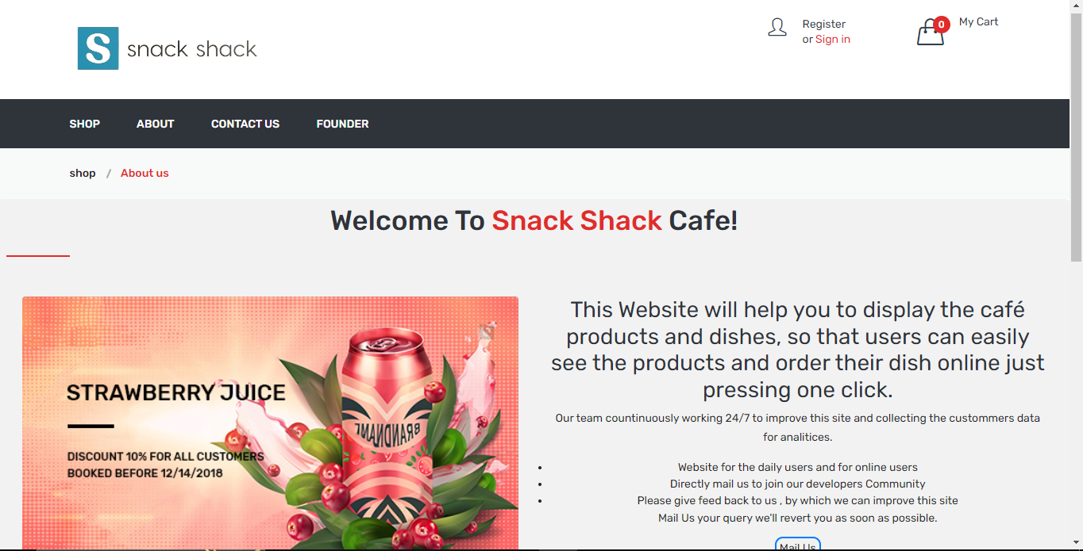

Figure 4.3.4[About Page]

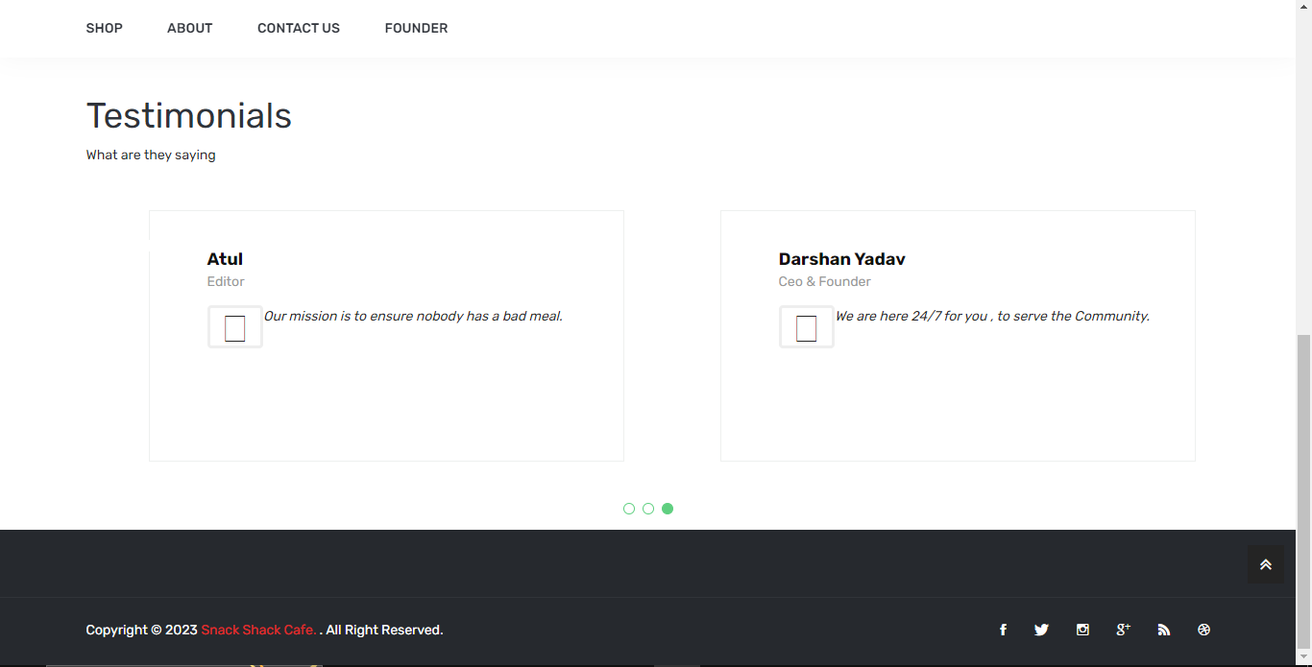

Figure 4.3.5[Testimonials Page]

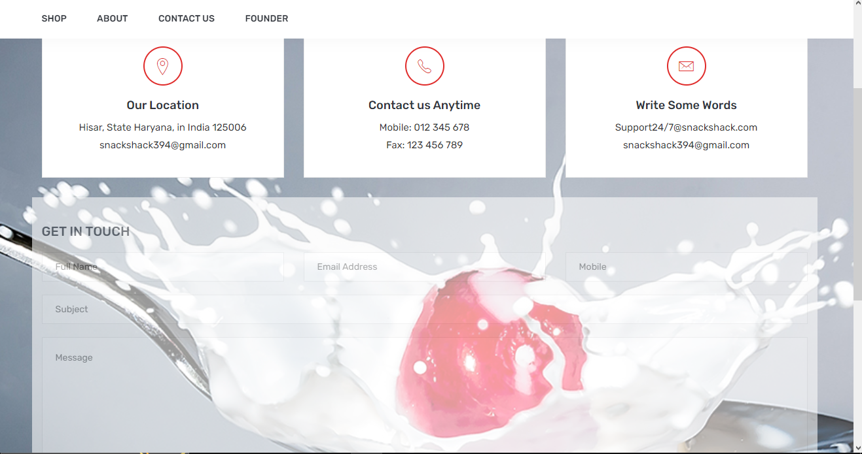

Figure 4.3.6[Contact Page]

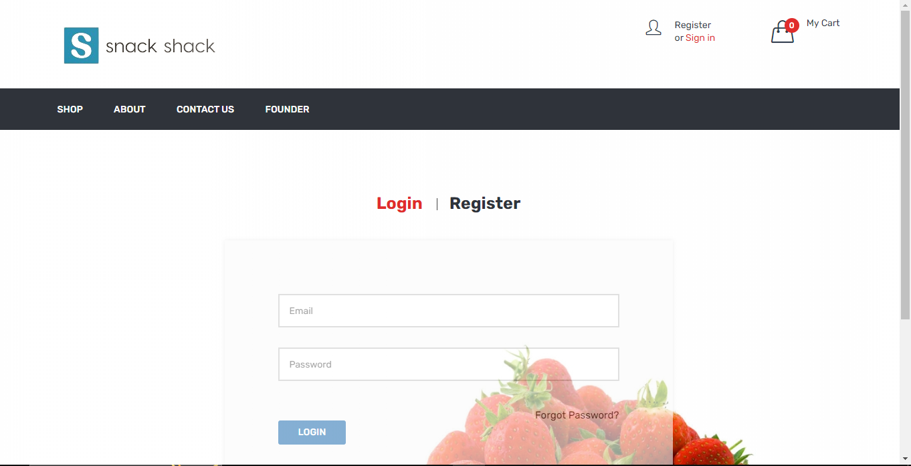

Figure 4.3.7[Login Page]

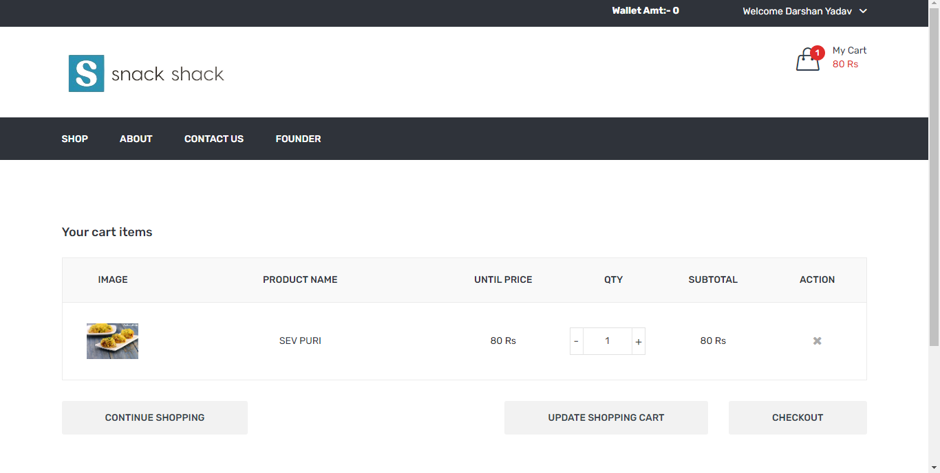

Figure 4.3.8[Cart Page]

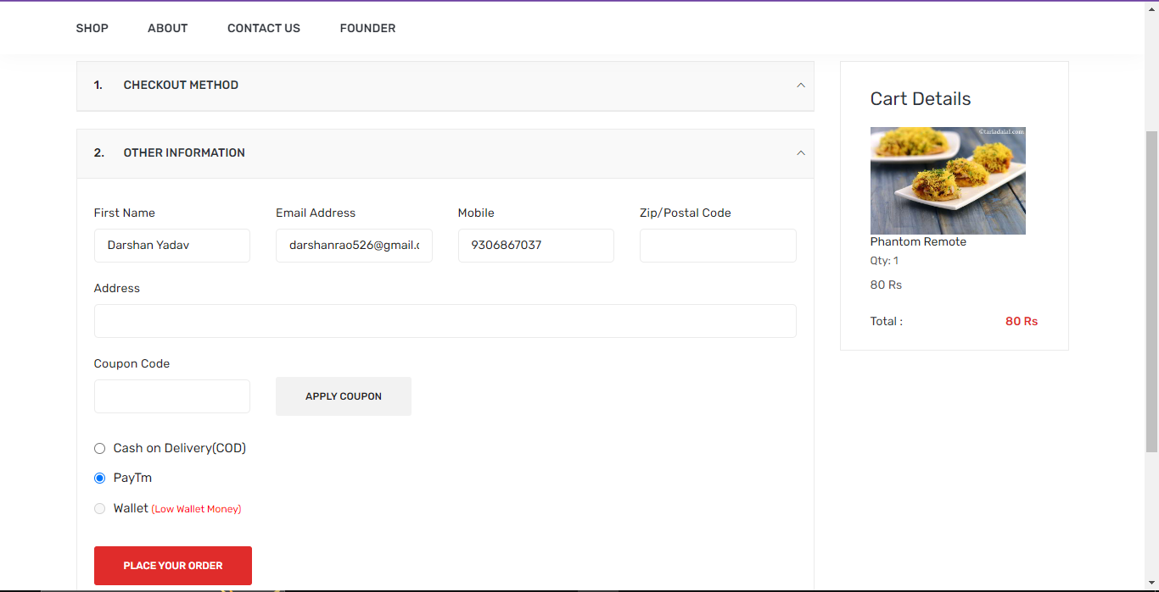

Figure 4.3.9[Checkout Page]

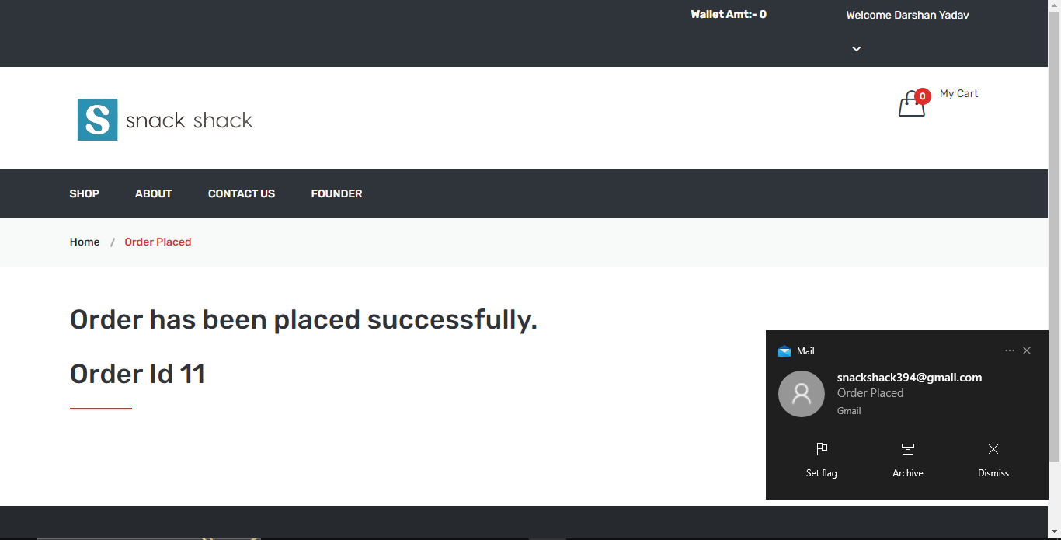Figure 4.3.10[Order Success Page and mail notification]

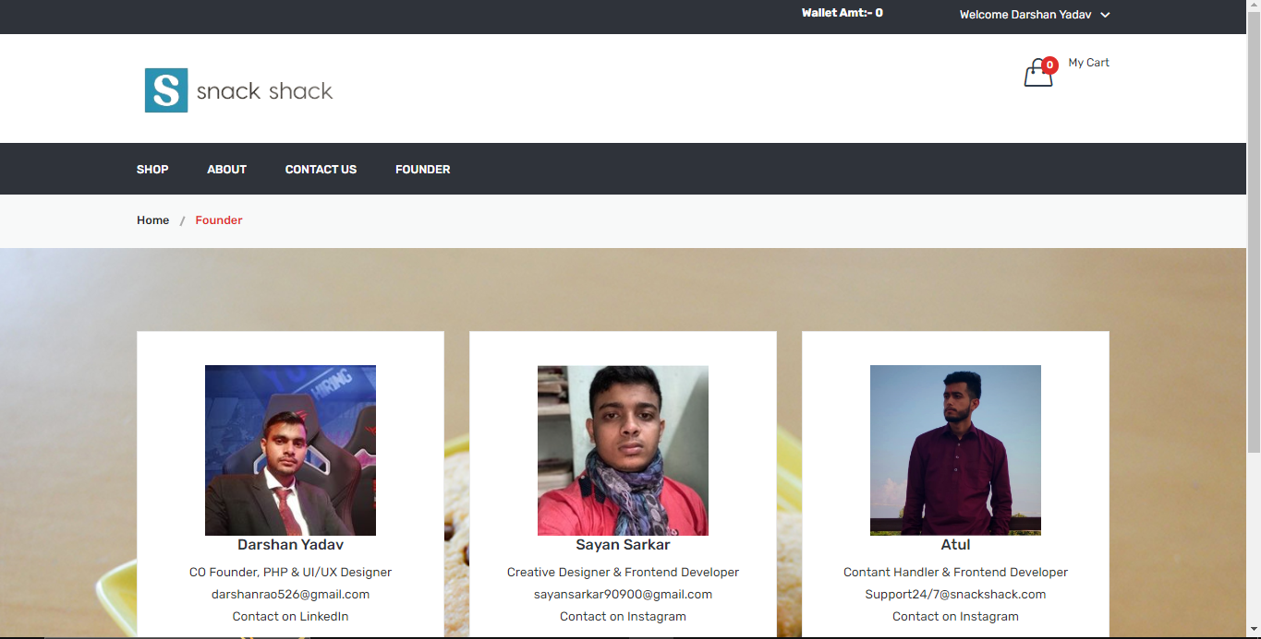Figure 4.3.11[Founder’s Page]

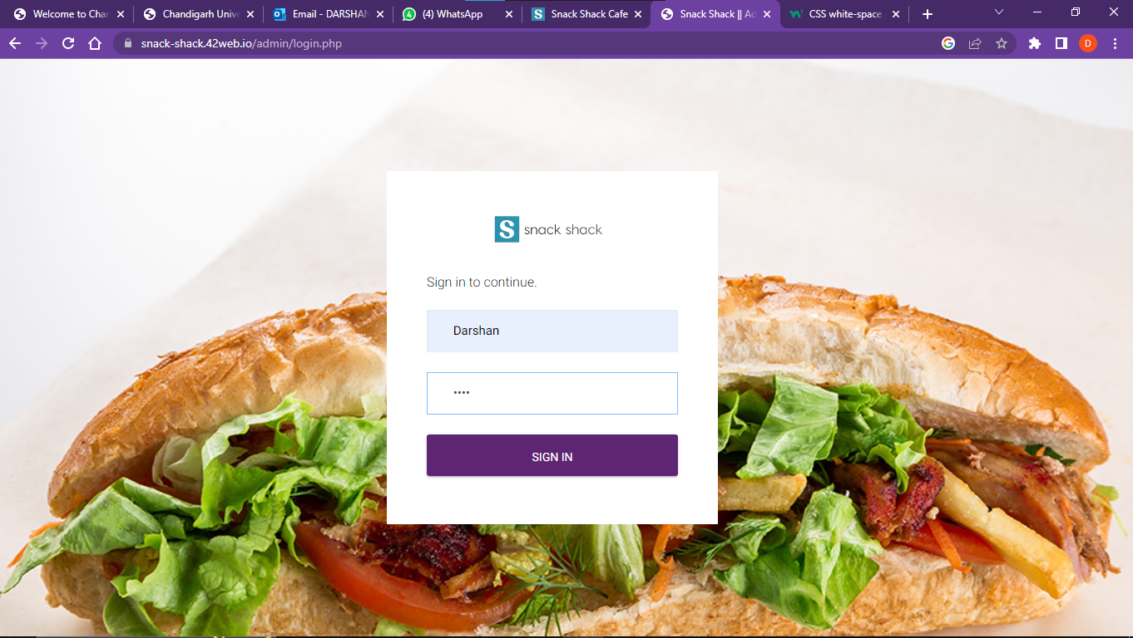

Figure 4.3.12[Admin Login Page]

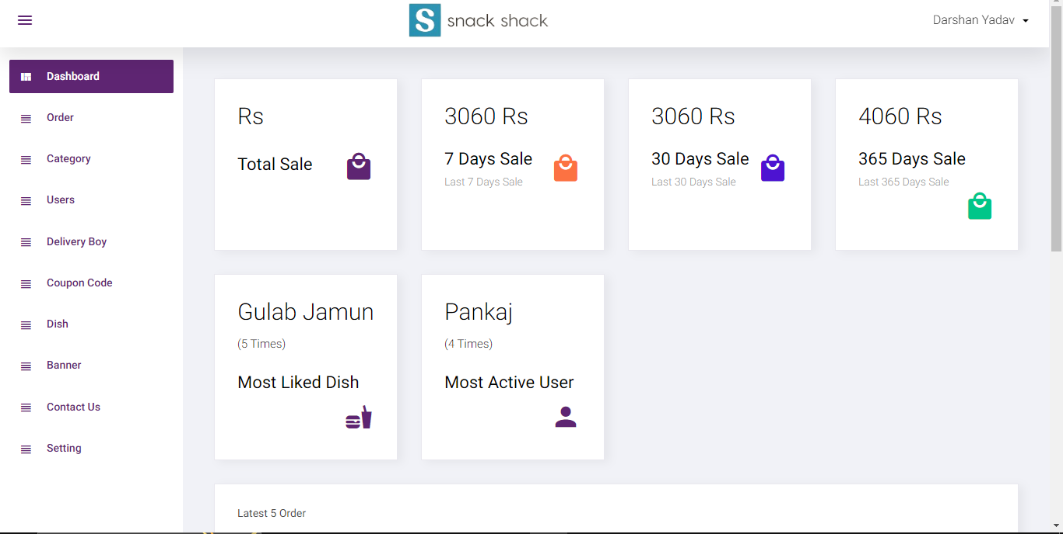

Figure 4.3.13[Admin Dashboard Page]

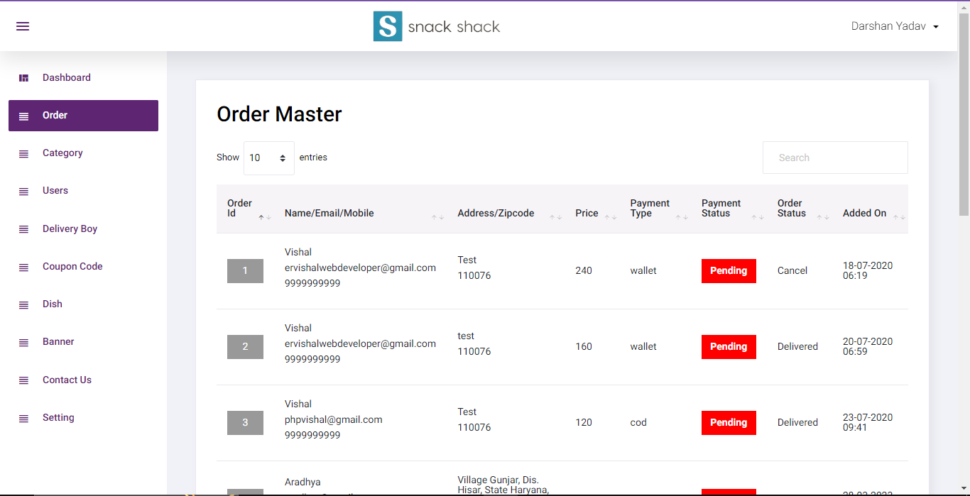Figure 4.3.14[Admin Order Master Page]

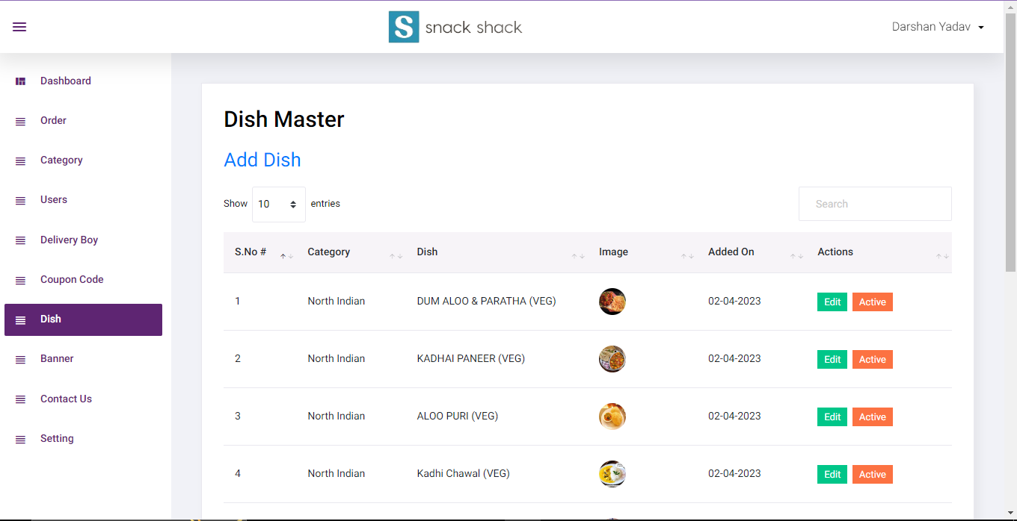

Figure 4.3.15[Admin Dish Master Page]

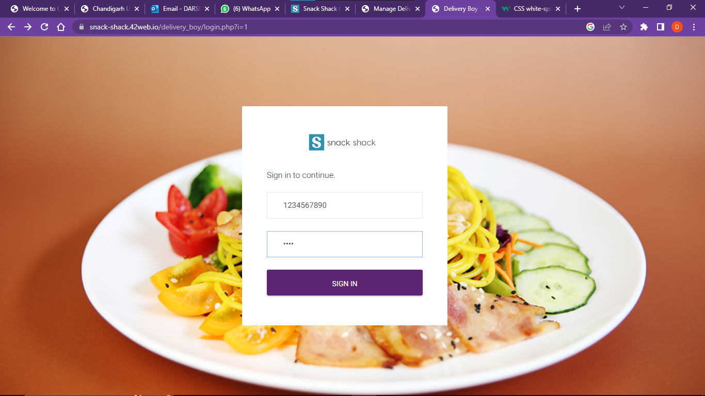

Figure 4.3.16[Delivery Boy Login Page]

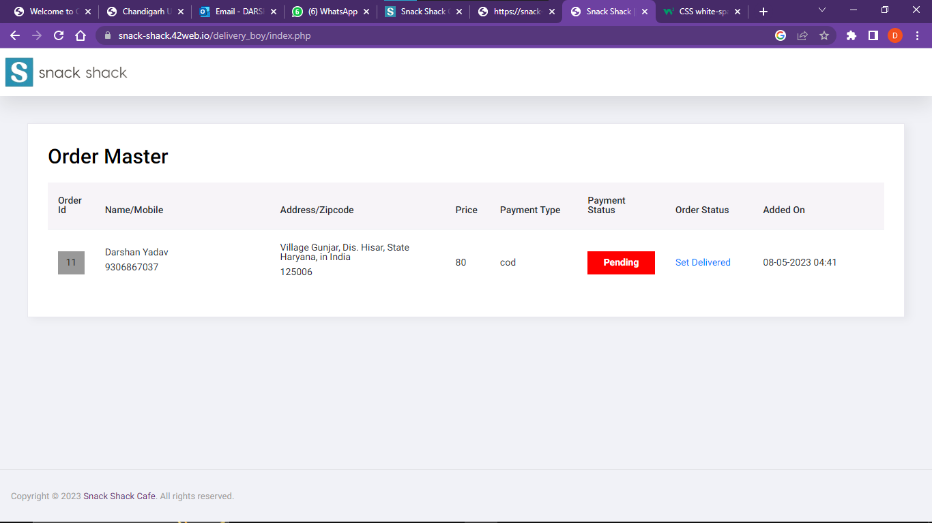

Figure 4.3.17[Delivery Boy Dashboard Page]

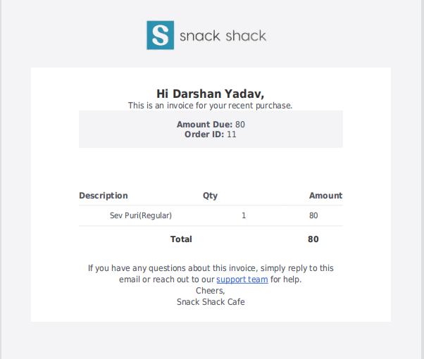

Figure 4.3.18[Order PDF]

**Chapter – 5**

**RESULT ANALYSIS AND VALIDATION**

Despite having a lot of constraints and risks, till now we have achieved the feat of minimizing them and we hope to do so in the upcoming phases of the project. After analyzing all the aspects of our project i.e. features and possible constraints, we have decided on certain features and possible constraints, we have decided on certain features for our project that will be suitable.

Major among them are listed below:

**Live Chat:** A feature where your operators initiate the chat and reach out to your website visitors by offering instant help. This is a powerful tool for increasing customer satisfaction and engagement. Snack Shack also provides AI chat bot for some common queries of users and provides new experience to the customers.

**Data Extend & format:** In feature updating the website our team make plane for adding new data, categories and voice searching for making the web smooth and attractive so that the sales and traffic of the café is increase in the website.

**Analytics and Reporting:** Analytics gives you visibility into key areas of your operation and is arguably the most defining feature of this software. We can use analytics to know which problems to attack first. We can analyze this using Customer or user data, time spending and menu analytics and Inventory and procurement analytics.

**Data Encryption:** The Snack Shack software is designed under encryption algorithms for securing form malicious attacks in the network in both side user and admin. So, before sending data to the database website can convert it into cipher text by using parity bit concept of encryption. The complete process makes it more secure.

**Interactive UI/UX:** The complete UI/UX is designed under user requirements. UI/UX of Snack Shack Café is simple and user interactive. If any new user comes he/she can very easily handle and order their Dish without any confusion.

**Chapter – 6**

**CONCLUSION AND FUTURE WORK**

**6.1 Deviation from expected outcome and ways ahead:**

The main outcome of this project is to manage the details of cafeteria, sales, database, and meals. It manages all the information about the cafeteria, meal type, and meal. The project is totally built at the administrative end and thus only the administrator is guaranteed the access. The purpose of the project is to build a website to reduce the manual work for managing the cafeteria. It tracks all the details about the sales, product, and meal.

There are the following outcomes that the project reach are:

* **Improve Customer Relationships:**

Well, the Snack Shack Café is designed on the basis of improving customer relationships. The website is very user friendly and very interactive. When any new user comes here he/she can easily handle or take their order in a few minutes at anytime and anywhere just pressing one click.

* **Tracking Sales:**

These days, the cafe maintains a huge amount of credit card and cash transactions too. Therefore, this Snack Shack café site helps to make life easy as the cafe manager by tracking all sales data using [Hybrid mobile app development](https://eibsglobal.com/hybrid-mobile-app-development/). With the help of this data, you will keep tabs on your items sold. This means Snack Shack Café also provides the power to make better decisions for your business.

* **Automatic Analysis:**

As a matter of fact, this Snack Shack cafe software can atomize the report generation. The site is designed in this way the admin can see all the reports of the café on their dashboard like the detail of products, cost, completed and progressed orders. In fact, it produces perfect reports on the impact of implemented marketing schemes like loyalty programs, and discounts, etc on consumer behavior. It helps the business to devise powerful future strategies to improve relationships with existing clients and get new ones.

* **Enhanced Productivity:**

The Snack Shack Café site all the products report or PDF to the admin. So this helps the admin to enhance productivity of the products very easily. So this is one of the most important outcomes of the Snack Shack Café website.

**6.2 Achievements:**

Well, we achieve the objectives of our project such as we made the Snack Shack Café site as a user friendly and very interactive user interface with AI embedded chat bot. We also designed and joined cart option and payment gate way. For storing the user’s data we use register and login page. Now come on the admin panel. The admin panel is very user friendly. Here the admin can add, delete and update any dish just pressing one click. Also the admin can see all the sales and profit of the café in admin panel. Finally, this website converts the tradition Restaurant or Café into online application.

**6.3 Future Scope:**

As we know people are going to do more importance to the time. People like to spend more and more time with technology. So the Snack Shack Café provides all the dishes at one place without going anywhere. Anyone can order there food just using the smart phone or tabs. It saves the time and money. The user can register or login and select the foods and pay the money. For proof website provide order pdf to the user. Delivery boy can deliver the item in the given time. Not only for users has this website also helped the café owner to handle all the sales very easily. It also provides updation facility to the owner. For solving common problems of the users and customers website provide AI or Machine Learning based Chat bot. In future we will go to add the recommendation option also in the Snack Shack Café. Recommendations help to increase the sales or customer interaction toward website.

**References**

**Article References:**

[1] [Alimul Rajee, “Online Food Ordering System”, Departement of ICT, Comilla University, 31 October, 2022](https://www.researchgate.net/publication/367179633_ONLINE_FOOD_ORDERING_SYSTEM)

[2] [Tejas Raibagi, Ashwin Vishwakarma, Jahnavi Naik, Rujata ChaudhariGeetanjali Kalme, “Orderista - AI-based Food Ordering Application”, IEEE Xplore, 12 April 2021](https://ieeexplore.ieee.org/document/9396040)

[3] [Cristina-Edina Domokos, Barna Sera, Karoly Simon, Lajos Kovacs, Tas-Bela Szakacs, “Netfood: A Software System for Food Ordering and Delivery”, IEEE Xplore, 08 November 2018](https://ieeexplore.ieee.org/document/8524854)

[4] [Tang Bin, Xu Hongzhen, Song Wenlin, “Wireless Food Ordering System Based on Web Services”, IEEE Xplore, 16 October 2009](https://ieeexplore.ieee.org/document/5288330/)

[5] [C. Branigan (2001), Wireless, handheld solutions prevail at NECC 2001, retrieved January 10, 2007](http://www.eschoolnews.com/news/showStory.cfm?%20ArticleID=2865)

**Website References:**

[6] *Gradle official website*, [online] Available: <https://gradle.org>

[7] W3 Schools official website, [online] Available: <https://www.w3schools.com>

[8] Bootstrap official HTML, CSS, JS template website, [online] Available: <https://getbootstrap.com>

[9] Swiper official website, [online] Available: <https://swiperjs.com>

[10] Youtube, [online] Available: <https://www.youtube.com>

**APPENDIX 1**

Snack Shack Cafe (Website)

### FINAL PROJECT REPORT

***Submitted by***

Darshan (20BCS2353)

Sayan Sarkar (20BCS2299)

Atul (20BCS2271)

***In partial fulfillment for the award of the degree of***

**BACHELOE OF ENGINEERING**

**IN**

COMPUTER SCIENCE ENGINEERING



**Chandigarh University**

MAY 2023

**APPENDIX 2**



**BONAFIDE CERTIFICATE**

Certified that this project report **“ Snack Shack Cafe (Website)”** is the bonafide work of “ **Darshan, Sayan Sarkar & Atul”** who carried out the project work under my/our supervision.

**SIGNATURE SIGNATURE**

**SUPERVISOR HEAD OF THE DEPARTMENT**

Submitted for the project viva-voce examination held on 15 May 2023

**INTERNAL EXAMINER EXTERNAL EXAMINER**